**Reasons Everyone Should Visit Rome, Italy, at Least Once**

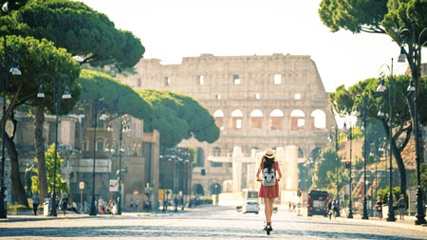

History awaits at every turn in Rome, Italy's grand capital

**cobblestone, sumptuous, world-renowned,**

Over 3,000 years of history can be found throughout the cobblestone streets in [Rome](https://theculturetrip.com/book/places-to-stay/17886666220996614107), and, from ancient monuments like the Colosseum to world-class art in Vatican City, the capital of [Italy](https://theculturetrip.com/book/places-to-stay/21745325693290658165) is packed with attractions. Here are Culture Trip’s top reasons to visit the Eternal City.

The capital of one of the most powerful ancient empires in the world, Rome is a fascinating place that has inspired people to visit for millennia. With incredible works of art, a leisurely pace of life and ………………………cuisine, [the Eternal City](https://theculturetrip.com/europe/italy/articles/the-essential-travel-guide-to-rome-infographic/) is worth a visit at least once, though it would take a lifetime to see all it has to offer. With Culture Trip, you can enjoy a guided bicycle tour of Rome and sample ………………………….culinary delights as part of [our exclusive 10-day Northern Italy adventure](https://theculturetrip.com/trips/explore-northern-italy-tour/) – led by our local insider.

Admire the ancient ruins

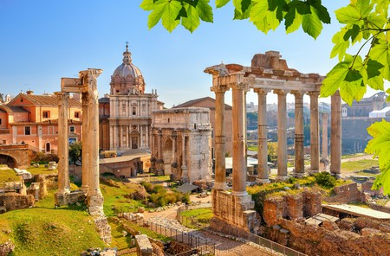

The ruins of the Roman Forum are a central ancient site

**incorporated, heritage, sight,**

Rome is a city built on layers. Here, you’ll find cascading ivy wrapped around ancient columns, ruins …………………….into modern structures, piazzas filled with the remnants of 2,000-year-old temples and cobblestones that date back millennia. The city is filled to the brim with visual records of its diverse time periods, and Rome remains an incredible ……………….to behold. Other ancient cities may have plenty of cultural ……………………on display as well, but, in Rome, this is so integrated into the present city that you will experience the breadth of its history at every turn.

Marvel at the architectural prowess

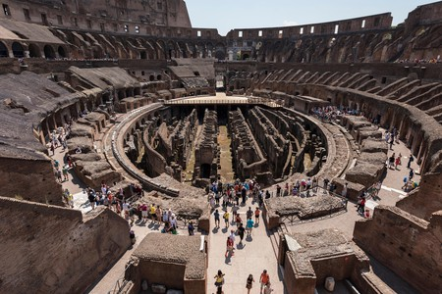

The impressive Roman Colosseum in Rome is a must-see

**lauded, venture, unsupported,**

The ancient Romans were …………………… for their architectural and engineering artistry, with testaments to their brilliance remaining throughout the city. A visit to Rome brings you up close with constructions that influenced building practices over centuries and across continents. Marvel at the [Colosseum](https://theculturetrip.com/europe/italy/articles/a-history-of-the-colosseum-in-one-minute/), the largest amphitheatre in the world, and the [Pantheon](https://theculturetrip.com/europe/italy/articles/10-things-you-didnt-know-about-the-pantheon-rome/), the largest …………………dome in the world. If you ……………………….. outside the historic centre, you’ll see Via Appia Antica, an ancient road that used pioneering cobblestone techniques, and the aqueducts that were an innovative way of transporting large quantities of water into the city.

Visit the seat of the papacy

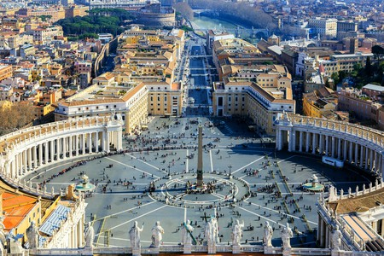

St Peter’s Square in Vatican City is a popular destination for tourists and pilgrims

**sacred, pilgrims, papacy,**

[Vatican City](https://theculturetrip.com/europe/italy/articles/a-locals-guide-to-vatican-city/), the smallest state in the world and the centre of the Roman Catholic Church, is one of the most ………………….places in Christendom. It is a big draw for tourists and ……………………..visiting Rome. Vatican City is located within Rome, close to the Prati district, and contains important religious and cultural sights such as St Peter’s Basilica and the Vatican Museums. It has been the seat of the …………………….. since the 14th century, and the pope holds an audience in St Peter’s Square each Wednesday morning.

Gaze up at the Sistine Chapel ceiling

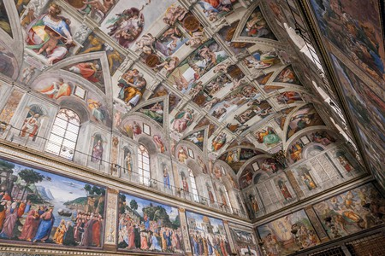

The Sistine Chapel ceiling is one of the key artistic sites in Rome

uncontested, restored,

The Vatican Museums are famous for their priceless sculptures, frescoes, tapestries and paintings, but the ………………………main attraction is the Sistine Chapel. It’s located within the Apostolic Palace, the residence of the pope, while its name comes from Pope Sixtus IV, who …………………….. it at the end of the 15th century. Michelangelo painted the cycle of frescoes on the ceiling of the Sistine Chapel between 1508 and 1512, and, today, it is considered one of the greatest works of art from the High Renaissance. You can take a virtual tour of the Sistine Chapel online, but seeing it in person is even more impressive.

Dine on Roman cuisine

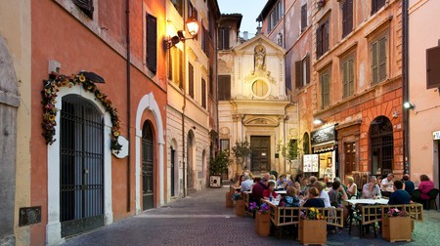

Dine like a local in Largo dei Librari square

Italian cuisine is beloved throughout the world, but few people realise that each region of Italy has its own unique dishes. To taste Rome’s famous*[cucina povera](http://theculturetrip.com/europe/italy/articles/the-16-essential-foods-you-need-to-eat-in-rome/)*(poor kitchen) dishes, you have to eat in a traditional trattoria in the Eternal City. Rome is lauded for its pasta dishes, including *amatriciana* (sauce with tomato and pork), *carbonara*(sauce with egg, cheese and pork), *gricia* (sauce with pork and cheese) and *cacio e pepe* (sauce with cheese and pepper) as well as its *pizza al taglio*, or pizza-by-the-slice – a favourite street food here. There is also a heavy Jewish influence in the cuisine, so you’ll find lots of artichokes, zucchini flowers and anchovies incorporated into the dishes. Be sure to try some delicious fried artichokes during your time in Rome.

Appreciate a balanced lifestyle

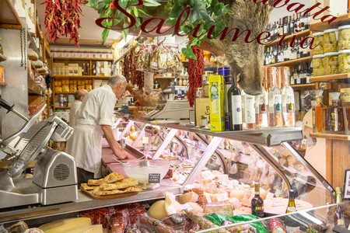

Visit a traditional Roman deli for some local flair

**epiphanies, seasonal,**

A visit to Rome will surely leave you with some ……………………during your trip. Yes, Italians often eat three-course meals with wine each day, and, yes, Italians eat a lot of carbohydrates. But they balance it out with vegetables, grains and meats. Travellers to Italy often worry about how they will maintain a healthy diet in the land of pizza and pasta, but Italian cooking strikes a balance between food groups and incorporates fresh, ……………………..ingredients into each dish. With regulations that protect farmers and consumers as well as an emphasis on locally sourced foods, you’ll be surprised how healthy you feel after eating out in Rome. The plenty of walking you’ll do while exploring the city won’t hurt either!

Embrace La Dolce Vita

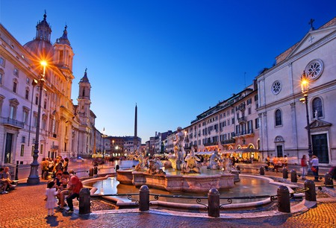

End the evening relaxing by the Fontana del Moro | © Hercules Milas / Alamy Stock Photo

**magnificent, stroll, basking,**

Italy, in general, is famous for its [*dolce vita*](https://theculturetrip.com/europe/italy/articles/10-films-that-will-make-you-fall-in-love-with-rome/) lifestyle, where everything is seen through rose-coloured glasses and real-life appears to be a never-ending vacation. Rome has its share of problems – such as bureaucracy, transportation and unemployment – but a visit to the city will have you leaning into its beauty and charms rather than the negatives. As you…………………. through the elegant piazzas, …………………..in the plentiful sunshine with a gelato in hand and bumping into …………………………sights such as the Trevi Fountain or the Spanish Steps, you’ll be sure to feel the magic.

Explore the diverse Quartieri

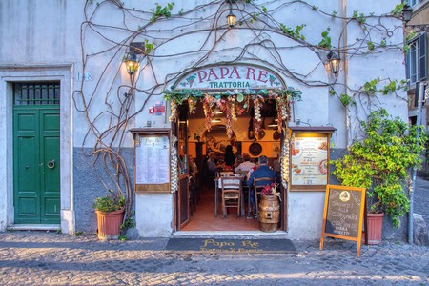

Dining at the historic trattoria Papa Re in Trastevere is a

**expansive, enclave, frenetic, eateries,**

Rome is comprised of dozens of diverse *quartieri* (neighbourhoods), and exploring these is one of the most rewarding aspects of a trip to this city. Rome truly feels like a set of villages combined into one …………………….capital, so you’ll soak in plenty of small-town charm everywhere you go. The well-trodden [Trastevere](https://theculturetrip.com/europe/italy/articles/trastevere-s-12-best-restaurants/), a Medieval neighbourhood located across the Tiber River, is a bohemian ………………………… with plenty of bars and………………….. that spill out onto the streets, while areas like San Lorenzo and Pigneto are popular with students and an alternative crowd.

Drop into a slower pace of life

Rome is located in the centre of Italy, but, in attitude and style, it is largely a southern city. The pace of life is slow, work hours are relaxed, and leisure is valued more than productivity. While this has some obvious negative consequences, living a slower pace of life also puts things into perspective, and Rome provides a welcome respite from the …………………….energy overtaking most of the industrial world. Work-life balance is important here, vacation is a right, and time is largely relative: plans aren’t made weeks in advance but often last-minute – just how Romans like it.